Fungicide Analysis:

|  |  |  |
| --- | --- | --- |
| # of samples tested | # of samples with detectable fungicides | % of samples with detectable fungicides |
| 636 | 166 | 26.10% |
| # of non-mig samples tested | # of non-mig samples with detectable fungicides | % of non-mig samples with detectable fungicides |
| 112 | 28 | 25% |

Morbidity Analysis:

|  |  |  |  |  |  |  |  |  |  |
| --- | --- | --- | --- | --- | --- | --- | --- | --- | --- |
| 2010-2013 | n | Mean | St. Dev | Min | Max | Percent infected at detectable level | Percent infected at threshold level | t-stat | p-value |
| Mites per 100 bees (Fungicides) | 11 | 4.02 | 4.02 | 0.53 | 14.93 | 100% | 45% | -0.97 | 0.34 |
| Mites per 100 bees (No fungicides) | 39 | 5.68 | 5.17 | 0 | 24.65 | 90% | 69% |
| Nosema per bee (Fungicides) | 11 | 0.12 | 0.16 | 0 | 0.4 | 45% | 0% | -0.88 | 0.38 |
| Nosema per bee (No fungicides) | 39 | 0.34 | 0.83 | 0 | 3.5 | 31% | 10% |

Top land covers (Aggregated):

|  |  |  |  |  |
| --- | --- | --- | --- | --- |
| Land cover | Mean - Fungi (ac) | Mean – No fungi | t-stats | p-value |
| Forested Uplands | 2013 (1531) | 2130 (2008) | -0.27 | 0.79 |
| Developed | 1848 (1972) | 1449 (2005) | 0.88 | 0.38 |
| Grasslands | 1167 (1010) | 1446 (1497) | -0.87 | 0.39 |
| Corn | 724 (1033) | 764 (1135) | -0.16 | 0.88 |
| Wetlands | 449 (554) | 286 (553) | 1.29 | 0.20 |
| Soybeans | 425 (699) | 419 (740) | 0.03 | 0.97 |
| Shrubland | 291 (561) | 344 (940) | -0.27 | 0.79 |
| Other Hay | 246 (338) | 154 (577) | 0.76 | 0.45 |
| Alfalfa | 92 (211) | 148 (361) | -0.75 | 0.46 |
| Grapes | 83 (370) | 2.39 (21) | 1.96 | 0.05** |
| Winter Wheat | 83 (198) | 151 (361) | -0.86 | 0.39 |

Top Land covers (Individual):

|  |  |  |  |  |
| --- | --- | --- | --- | --- |
| Land cover | Mean - Fungi (ac) | Mean – No fungi | t-stats | p-value |
| Deciduous Forest | 1297 (1432) | 1482 (1766) | -0.48 | 0.64 |
| Grassland Pasture | 1167 (1010) | 1437 (1504) | -0.90 | 0.37 |
| Developed Open Space | 751 (1033) | 544 (541) | 0.87 | 0.39 |
| Corn | 724 (1033) | 764 (1135) | -0.16 | 0.88 |
| Developed w/ Low Intensity | 664 (853) | 426 (678) | 1.43 | 0.15 |
| Evergreen Forest | 502 (958) | 343 (1027) | 0.69 | 0.49 |
| Soybeans | 425 (699) | 419 (740) | 0.03 | 0.97 |
| Shrubland | 291 (561) | 344 (940) | -0.27 | 0.79 |
| Mixed Forest | 214 (579) | 275 (896) | -0.32 | 0.75 |
| Developed w/ Med Intensity | 282 (485) | 269 (628) | 0.09 | 0.93 |
| Developed w/ High Intensity | 150 (362) | 210 (628) | -0.45 | 0.65 |
| Woody Wetlands | 378 (548) | 184 (357) | 2.07 | 0.04 ** |

Detection Time:

|  |  |
| --- | --- |
| Month | Count |
| Jan | 0 |
| Feb | 0 |
| Mar | 0 |
| Apr | 1 |
| May | 0 |
| Jun | 0 |
| Jul | 4 |
| Aug | 8 |
| Sep | 3 |
| Oct | 3 |
| Nov | 3 |
| Dec | 0 |
| n=22 | |

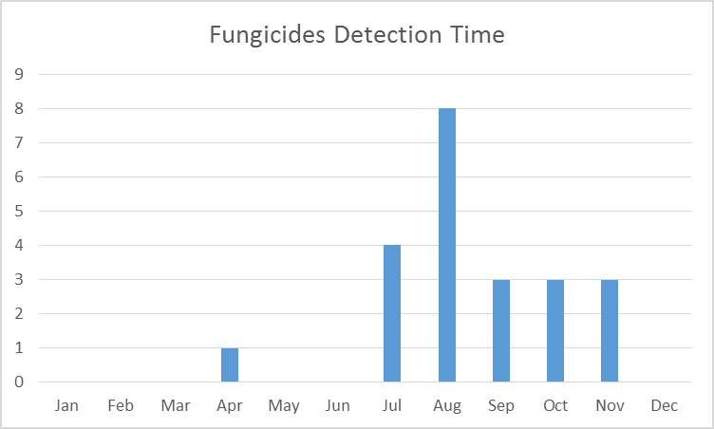

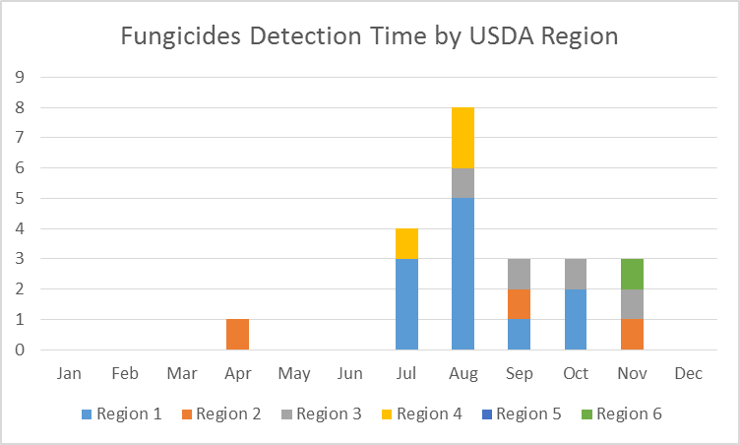

Fungicide pesticides have been detected in April and from July to November. In April, fungicide was detected in warm state Tennesse. Then, these pesticides have been detected in colder states from July to October and the detection moves back to warm states (FL, CA, GA) in November.

